ASSIGNMENT-4

Write code and connections in wokwi for the ultrasonic sensor. Whenever the distance is less than 100 cms send an "alert" to the IBM cloud and display in the device recent events. Upload document with wokwi share link and images of IBM cloud.

//ASSIGNMENT -4

#include <WiFi.h>

#include <PubSubClient.h>

void callback(char* subscribetopic, byte* payload, unsigned int

payloadLength);

//enter the credentials

#define ORG "46kqz9"

#define DEVICE_TYPE "raspberrypi"

#define DEVICE_ID "123"

#define TOKEN "12345678"

String data3;

char server[] = ORG ".messaging.internetofthings.ibmcloud.com";

char publishTopic[] = "iot-2/evt/Data/fmt/json";

char subscribetopic[] = "iot-2/cmd/test/fmt/String";

char authMethod[] = "use-token-auth";

char token[] = TOKEN;

char clientId[] = "d:" ORG ":" DEVICE_TYPE ":" DEVICE_ID;

WiFiClient wifiClient;

PubSubClient client(server, 1883, callback ,wifiClient);

const int trigPin = 5;

const int echoPin = 18;

#define SOUND_SPEED 0.034

long duration;

float distance;

void setup() {

**Serial**.begin(115200);

pinMode(trigPin, OUTPUT);

pinMode(echoPin, INPUT);

wificonnect();

mqttconnect();

}

void loop()

{

digitalWrite(trigPin, LOW);

delayMicroseconds(2);

digitalWrite(trigPin, HIGH);

delayMicroseconds(10);

digitalWrite(trigPin, LOW);

duration = pulseIn(echoPin, HIGH);

distance = duration * SOUND_SPEED/2;

**Serial**.print("Distance (cm): ");

**Serial**.println(distance);

if(distance<100)

{

PublishData(distance);

**Serial**.println("ALERT!!");

delay(1000);

delay(1000);

if (!client.loop()) {

mqttconnect();

}

}

delay(1000);

}

void PublishData(float dist) {

mqttconnect();

String payload = "{\"distance recorded is \":";

payload += dist;

payload += ",\"ALERT!!\":""\"the recorded distance is less than 100cm\"";

payload += "}";

**Serial**.print("Sending payload: ");

**Serial**.println(payload);

if (client.publish(publishTopic, (char*) payload.c_str())) {

**Serial**.println("Publish ok");

} else {

**Serial**.println("Publish failed");

}

}

void mqttconnect() {

if (!client.connected()) {

**Serial**.print("Reconnecting client to ");

**Serial**.println(server);

while (!!!client.connect(clientId, authMethod, token)) {

**Serial**.print(".");

delay(500);

}

initManagedDevice();

**Serial**.println();

}

}

void wificonnect()

{

**Serial**.println();

**Serial**.print("Connecting to ");

WiFi.begin("Wokwi-GUEST", "", 6);

while (WiFi.status() != WL_CONNECTED) {

delay(500);

**Serial**.print(".");

}

**Serial**.println("");

**Serial**.println("WiFi connected");

**Serial**.println("IP address: ");

**Serial**.println(WiFi.localIP());

}

void initManagedDevice() {

if (client.subscribe(subscribetopic)) {

**Serial**.println((subscribetopic));

**Serial**.println("subscribe to cmd OK");

} else {

**Serial**.println("subscribe to cmd FAILED");

}

}

void callback(char* subscribetopic, byte* payload, unsigned int payloadLength)

{

**Serial**.print("callback invoked for topic: ");

**Serial**.println(subscribetopic);

for (int i = 0; i < payloadLength; i++) {

//Serial.print((char)payload[i]);

data3 += (char)payload[i];

}

**Serial**.println("data: "+ data3);

data3="";

}

ESP32 SCREENSHOT:

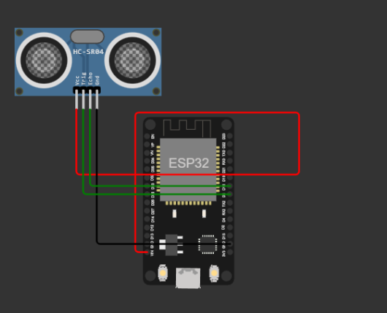

IBM cloud events screenshot:

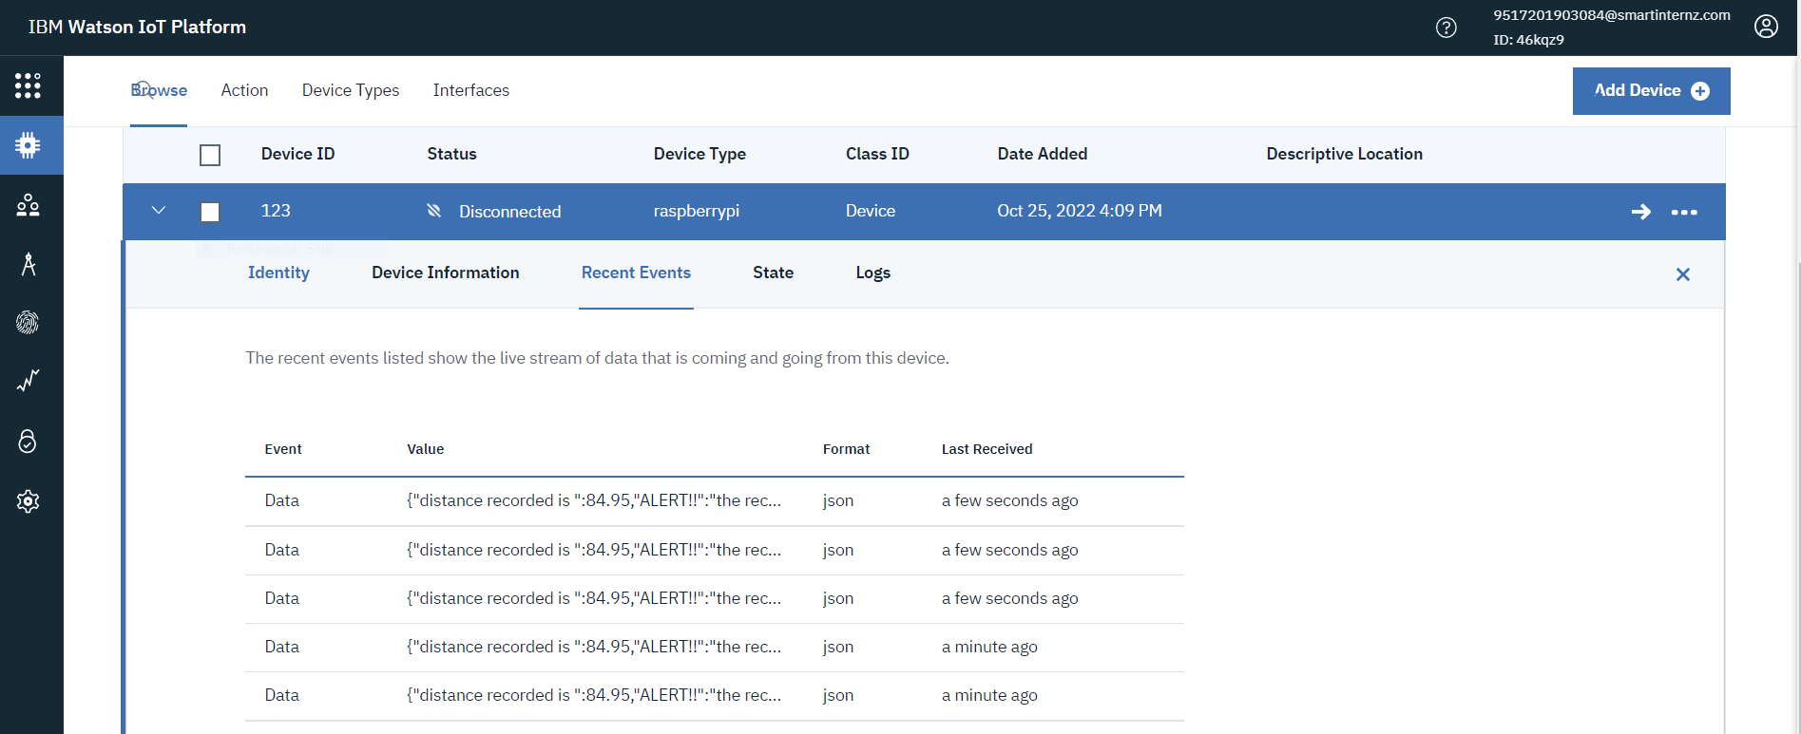

[sketch.ino - Wokwi Arduino and ESP32 Simulator](https://wokwi.com/projects/347028773215928914)